**Strategy proposal for Merck & Co. Inc.**

Presented to

Danilo Messinesse, Ph.D., Professor of Management Tools & Principles.

Prepared by

Teresa Adriana Sánchez Blanco, Francisco Rivas, Luana Raimundo Rocha-Kahale, Alejandro Rodríguez, Elena Publie, Martina Ramosaco, Soren Luca Schmid.

Bachelor in Business Administration, IE University.

15th December, 2023

**Index**

Contents.

1. The Problem Merck Faces3

2. Introducing AI and its Applications3

3. Strategic Partnering with MindRank5

4. How AI Would Be Financed6

5. Entering the Asian Market7

6. Plan Development for the Asian Market8

**Annex12**

**References16**

1. The Problem Merck Faces.

After conducting a thorough analysis of MERCK, we have identified a significant concern: Merck’s excessive dependence on the U.S. market and their drug Keytruda together with the actual quick macroeconomic and demographic shifts, and technological disruptions. We discovered that their drug Keytruda made up 30% of the company's sales while having a big reliance only on the U.S. market (50% of its sales comes from the US). To address this concern, we recommend exploring potential strategies that could improve MERCK's performance in the pharmaceutical market: 1) Entering emerging markets such as India, Indonesia, and China; 2) Introduce AI to develop new drugs, reduce costs, and improve overall performance.

2. Introducing AI and its Applications.

According to Deep Pharma Intelligence (Deep Pharma Intelligence, 2023), 700 companies are actively developing AI-driven technologies. The amount of capital invested in AI for the industry has grown from $2.28B in 2020 to $126B in 2022, and it is expected to go over $300B in 2025. The Tufts Center for the Study of Drug Development released a study showing that the cost of developing a new prescription drug that gains market approval is $2.6B plus an average of 10 years of investigation (Mullard, 2020). Thanks to the Computer-aided drug design, led by the AI revolution, the pharma industry is going to shift towards a data-centric approach. As an example of the potential of the AI application in Merck’s operations, we have Insilico Medicine, which is a company founded in 2014 by Alex Zhavoronkov and Feng Ren (Deep Pharma Intelligence, 2023). In 2021, Insilico Medicine managed to go from Disease Hypothesis and target Identification to Candidate Validation in just 11 months, with a total expenditure of $850,000. With the traditional method of drug design, the process until candidate validation would have taken at least 2 years and almost $700 million invested.

AI and Machine Learning methods can be applied for a variety of uses. However, we consider that the most important ones to apply at Merck would be (Vora, L. K. & Gholap, A. D., 2023):

1. AI for Drug Discovery: It is used for target identification by examining datasets including genetic, proteomic, and clinical data to find possible targets for treatment. Virtual screening is used for prioritizing and choosing substances for experimental testing is made easier for researchers by simulating chemical interactions and forecasting binding affinities. In addition, drug candidates can be analyzed and optimized by AI algorithms that take into account a variety of factors, but also be able to find medications that might be useful in treating various illnesses. Toxicological databases are used to train algorithms that can predict negative outcomes or dangerous structural characteristics. The identification, optimization, and development of novel therapeutic candidates can be facilitated and expedited by the use of artificial intelligence (AI) techniques in drug research and development. Consequently, this may result in the creation of medications that are more potent and efficient.

2. AI for Drug Delivery. Through multiscale modeling, computational pharmaceutics, a branch of pharmaceutics, improves drug delivery through the integration of AI and big data. Large datasets are analyzed, drug behavior is predicted, and development is accelerated by AI algorithms. By simulating formulation processes, researchers can expedite timelines and save costs while optimizing drug delivery. From the molecular to the macroscopic levels, drug delivery is modeled by computational pharmaceutics, providing a thorough understanding. Predicting physicochemical characteristics, stability, and in vivo pharmacokinetics is made easier by this technology. By using AI tools, risks can be identified early, allowing for proactive modifications and less reliance on expensive trial-and-error experiments.

3. AI to Reduce Costs: MERCK can decrease its R&D costs by implementing Artificial Intelligence, which can lead to a boost in MERCK´s data analysis, experimentation, forecasting, creativity, and innovation while achieving superior R&D outcomes and value. For example, the implementation of Artificial Intelligence can help MERCK automate an abundance of data collection, analysis, and interpretation which will reduce labor costs, and therefore MERCK´s researchers can focus on a wider variety of research initiatives. Artificial Intelligence algorithms will make pharmaceutical manufacturing uniform and efficient by analyzing large amounts of data to inform regulatory decisions. Additionally, Artificial Intelligence can help R&D teams identify patterns and trends and make predictions to inform research and development efforts.

However, there are limitations of AI tools such as the lack of transparency where a model's prediction process is so opaque that not even the designers of some of the most sophisticated algorithms ever created can fully comprehend it. Biosystem complexity can also be considered a limitation as artificial intelligence models frequently oversimplify and abstract the biological processes that underlie them. In order to identify patterns and anticipate outcomes, they depend on training data, which might not adequately encompass the subtleties and complexity of biological systems. AI algorithms usually work within a statistical framework, which may restrict their ability to understand the complex relationships and significant impacts that particular parameters may have. AI models are challenged by the complex nature, where treatment decisions are influenced by multiple unique factors.

3. Strategic Partnering with MindRank.

We have chosen MindRank as our partner to implement AI in our R&D processes. MindRank is a Chinese company founded in 2021 and headquarted in Shangai. MindRank was awarded as the best AI company in the “Global Artificial Intelligence Innovation Contest” held in Hangzhou, China, in June of 2021, and since then it has received funds from many institutional and private sources, such as Sherpa Healthcare and the European Innovative Medicines Initiative, and has partnered with several enterprises and top universities, such as Cambridge University or Peking University (MindRank, 2023).

MindRank pipeline is specially developed in Oncology and Diabetes, which match with Merck’s pipeline and best-selling products (Keytruda and Januvia). The oncology market is expected to go from 20 million in 2023 to 30.2 million of cases in 2040 (Statista, 2023); 1 in 2 adults is expected to be obese by 2030 in the US (Chew, Chong & Min Kuo, 2023); and diabetes is expected to reach 10.4% of the total world population by 2040 (Saklayen, 2023). Metabolic diseases and obesity are expected to increase 194% and 294%, respectively, from 2025 to 2050 (Chew, Chong & Min Kuo, 2023)[1].

The terms of our partnership would be: A 5-year exclusive strategic alliance in which $15B will be invested. The first $7B would be invested in 2024 to cover initial costs and accelerate the implementation of AI in our processes. The next $8B would be distributed in the following 4 years. If we want to keep the leadership in our industry, we consider that this decision is necessary. To decide the amount of money invested, we have looked at Sanofi’s deal with Exscientia, a top leading AI pharma company, of $5.2B (Deep Pharma Intelligence, 2023) Sanofi is one of our competitors and has a similar size (around $46B in revenue in 2022) (Sanofi, 2022), so tripling the amount of money they have invested considering AI future applications and developments would be key to stay ahead in our industry.

Lastly, to further strengthen our innovation efforts, we have decided to increase the fixed R&D costs by 6% annually, although we expect our total revenue just to increase by 4% annually[2]. Keeping in mind Merck’s correlation between increase in R&D and increase in profits observed since 2014[3], this would most likely result in greater sales in the long run as a result of the discovery of new drugs and the optimization of our processes.

4. How AI Would Be Financed.

Merck is currently investing $57B in Treasury Stock. Our main idea is taking part of the capital that is being invested there and use it to fund our partnering alliance with Mindrank. This strategy, however, has a great problem when it comes to the value of its stock. If the firm is going to invest around $15B less in Treasury Stock, the most probable outcome is that the stock price is going to be affected. However, we consider that the short-term efforts and problems are well worth it to face if we want to keep our leadership in the long-term. Furthermore, Merck has demonstrated its liquidity and stock resilience with constant billionaire expenditures to acquire companies or to develop strategic alliances and collaborations. For example, the purchases of Prometheus Inc. and Imago BioSciences has costed Merck around $11B and has reduced its net income from $11.5B in 2022 to $1.6B in 2023 (Merck, 2023), since they have added this purchase as an R&D expenditure. However, this great variation in net income has not affected much the stock price, because investors know that the company is taking good long-term decisions although its income statement or balance sheet may seem “worse” with a superficial analysis. Merck cash and cash equivalents as of September 30, 2023, were $8.7B, which also demonstrates our strong financial power to keep investing without the need of leverage or diluting our stock.

Our main idea is taking as much money as possible from Treasury Stock despite its risk of lowering the stock price, since it won’t damage as much our cash flow statements and would allow us to finance our operations with our own money. Nevertheless, the stock prince would be monitored and, if it starts to decrease drastically, corrective action would be implemented and funds would be used from other sources, such as cash, bonds, commercial paper or long-term loans. Our company’s good financial status and credit ratings[4] allows us to finance our operations and investments from many different sources, which is a competitive advantage that we should exploit.

5. Entering the Asian Market.

The world's financial and technological center is shifting to the most fast-growing region of the globe: Asia. This region is poised to become the world leader, marking a significant shift in global power dynamics and economic dominance. These high-populated countries such as China and India need strong public healthcare systems to deal with diseases, from detection to treatment phase. Recognizing this shift, it is imperative for Merck to realign its strategic focus and adapt to this evolving landscape, instead of focusing their activity blindly on the U.S. market where 50% of their revenue comes from (Merck, 2022). Moreover, the US market has been weighed down by growing regulations, such as the Inflation Reduction Act of 2022[5], and purchasing power in free fall since 2007.

By strategically addressing emerging economies with high populations, Merck can establish itself as a key player in meeting the healthcare needs of diverse populations around the world. Emerging countries are the world’s biggest markets, representing 60% of the world’s worldwide population and all experiencing the biggest perceptual GDP growth in their history. Asia has the biggest share of the world GDP as well, accounting for 46% of it (Seong and Bradley, 2023). For instance, the GDP per capita in China is expected to rise from 17.744 in 2023 to 24.300 in 2027. That is a 36% rise in less than 4 years which is a tremendous increase. Additionally, China is now the biggest economy with a GDP of $30 trillion. These nations are experiencing an increase in purchasing power[6], presenting an ideal opportunity for Merck to expand, especially given the relatively lax regulations in those regions. For instance, the incidence of diabetes and oncologic diseases is expected to grow by 20% or more by 2030 in emerging countries (Tannoury & Attieh, 2017). The incidence of Obesity, Hypertension and Hyperlipidemia is expected to grow tremendously in markets such as China, India and Malaysia as they adopt a more sendentary or “western” lifestyle (Chew, Chong & Min Kuo, 2023)[7]. Merck could help discover, develop, and deliver effective and safe medical treatments in emerging countries by improving patient health outcomes in these high-speed growing populations while ensuring sustainable business growth through innovation and commercial success.

6. Plan Development for the Asian Market.

We would build an 800,000 square meter manufacturing plant in the outskirts of Medan, Indonesia[8]. The total cost of purchasing the land would be $538.6 million, as the cost per square meter in $673 (Timmermans, 2023), which would be paid in cash. The construction of the plant is estimated to cost around $1B, after studying similar constructions of our competitors and our firm, which incurred in restructuring costs of about $4B over the last 5 years to improve its plants (Merck, 2022). The funds for the construction would be taken from Treasury Stock. However, the cost of this transaction could be lowered if we collaborate with the local and national government. Our new plant will have a great positive impact on the development of the city, the communities surrounding it and the whole nation, so we could benefit from tax exemptions, subsidies and other governmental helps. We have chosen Indonesia for this project for several reasons. First, its strategic position opens us the possibility to easily reach the profitable markets of India, Singapore, Malaysia, China, Vietnam and Thailand, reducing transportation costs. Second, property, day to day supplies, manpower and the overall cost of operating there is cheaper. Third, Indonesia is near the main centers of AI and engineering development of the world, Singapore and China. With the Tsinghua University, the National University of Singapore and the Chinese University of Hong Kong as the top 3 universities in AI respectively (U.S. News, 2023), we will have easier access to the best recruitment centers for our future scientists and researchers.

Our main goal is to produce Keytruda together with other top selling medicines in this new plant and sell it to our target markets. However, we need an adjusted pricing strategy in the different countries we are targeting. This is the strategy we would follow to price Keytruda in our different target countries:

First, we take the price paid by the patient for the drug in the US as reference price. The real price of Keytruda is $192,000 in the US (Keytruda.com, 2023), but 99% of it is covered by governments and insurance companies. Thus, the patient pays around $1906 yearly[9] or 2.36% of the annual GDP per capita, which is $80,400 (IMF, 2023). Now, we have to adjust Keytruda’s share of US GDP per capita to the rest of our target countries[10], so it does not go above 2.4% of their annual income[11]:

1. India: $220 yearly.
2. Malaysia: $889 yearly.
3. China: $559 yearly.
4. Indonesia: $380 yearly.

It is key to develop partnerships and agreements with national governments, insurance companies and other health care entities in order to introduce Keytruda in those markets, as they pay the majority of the treatment, and our products would be directly sold to them. We will approach these negotiations highlighting the superior quality of our drugs and our intention to operate in those countries in the long-term. It would take Merck at least 2 years to build the new manufacturing plant, develop partnerships and agreements, hire the staff and complete all bureaucratic procedures to establish the company there.

If we get to introduce Keytruda in those markets, we have estimated a revenue of $20.6B in 2026, which would grow until around $36.8B in 2030. To make these estimations, we have followed the next process:

The real cost of Keytruda in the US in $192,000 yearly, which represents 2.37 times the individual annual income of the country ($80,400). Now, taking US prices as reference, we adjust the real price of Keytruda to the average GDP per capita of our target market[12], which is $17,600. We do this by multiplying the average GDP of the target market by 2.37, which gives us an average price of $41,880 yearly for Keytruda. Once we have the price of Keytruda, we need to estimate the number of people we would be able to reach. Of the 20 million people with cancer in the world, around 50% are in Asia (WHO, & International Agency for Research on Cancer, 2021). Of the 10 million patients, we have estimated a conservative market share of 5%, since Keytruda does not treat all types of cancers, there is a lot of competition targeting the same market and we don’t have the production capacity to serve them all. That 5% market is, in fact, the current Merck’s market share (Statista, 2023), so that is another reason why we estimated a 5% reach, which would be around 500,000 patients. Multiplying the number of patients we would be able to serve and the average cost of Keytruda, we have the total expected revenue. For more details into how we have estimated the revenue until 2030, please go to the Annex (Note 10)[13]. You will also find there the excel file with the calculations.



**Annex**

Note 2: R&D and Total Sales Projections.

-R&D expenses projections:

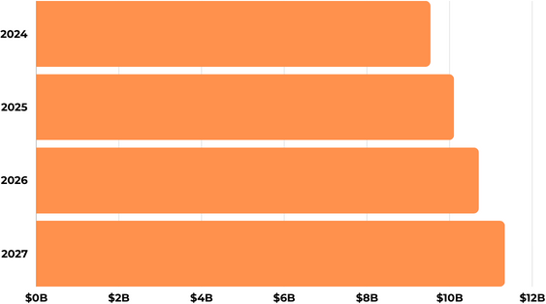

- Total Sales Projections:

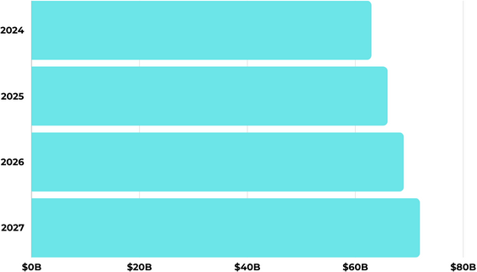

Note 3: Charts of R&D expenses and Net Income since 2015.

- Merck’s R&D expenses are shown in purple, compared to Pfizer (green) and JNJ (in pink).

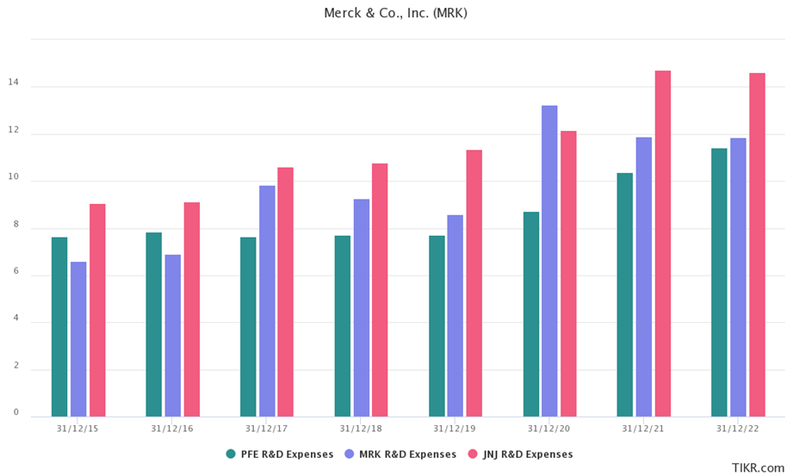

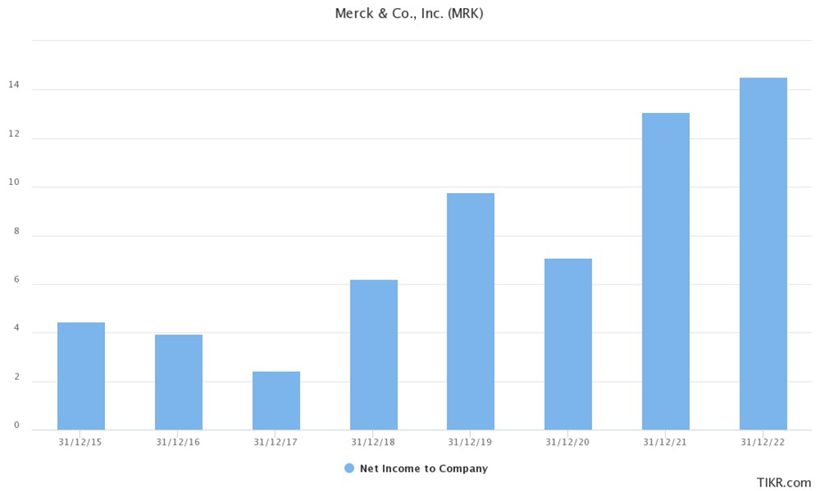

Note 6: GDP forecasts of India, China, Indonesia, South-East Asia, India and East Asia (Purchasing Power Parity).

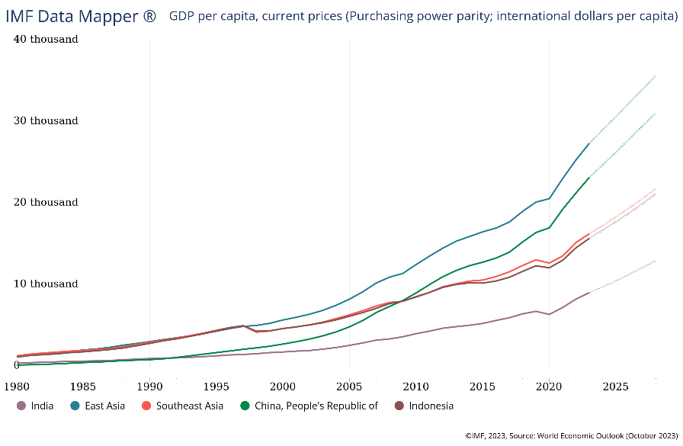

Note 7: Graph comparing the trend of different metabolic diseases until 2050 in China, India and Malaysia.

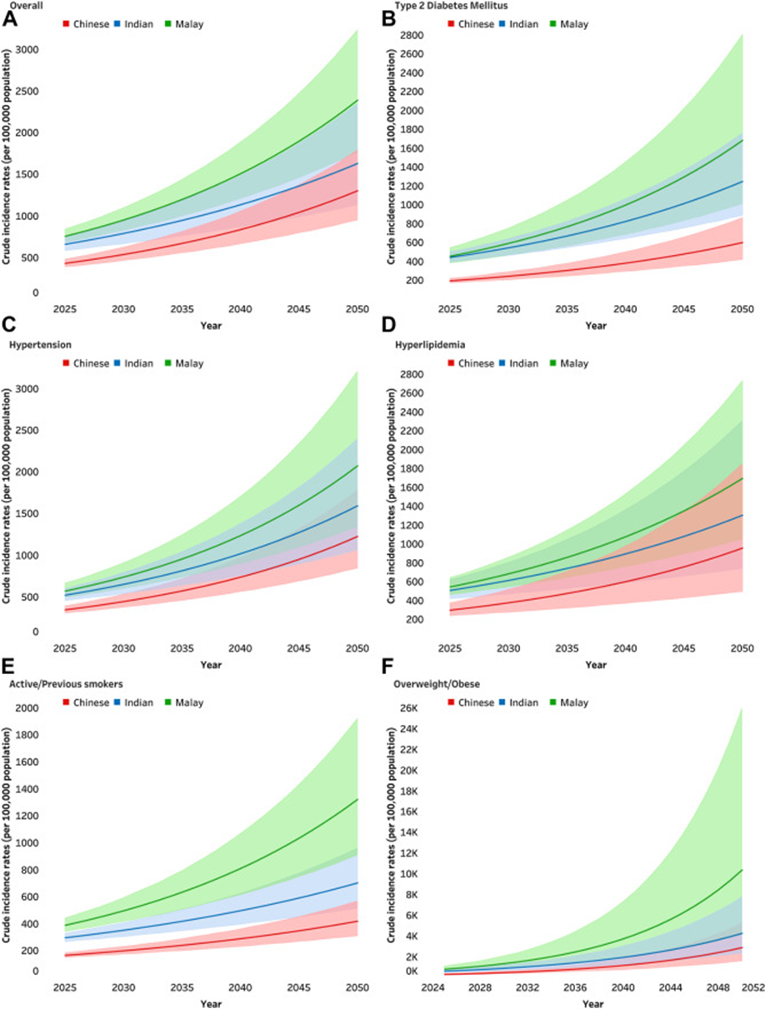

Note 8: Location of Medan, Map.

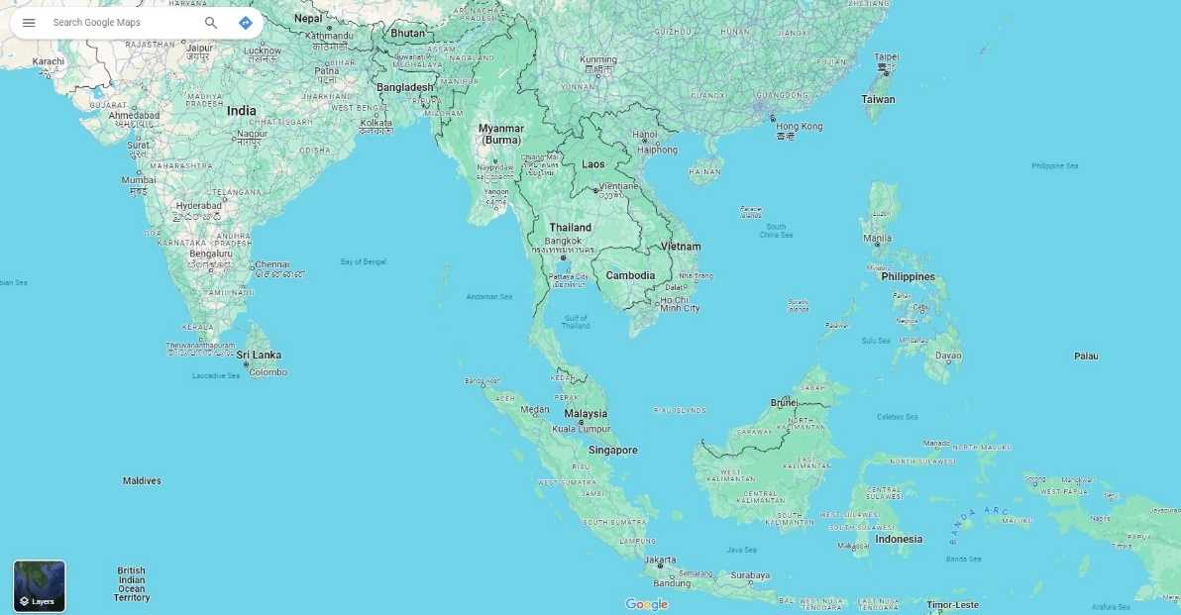



Note 9: As of 2017, the average price per three-week dose in the US was $87 (IFHP, 2019). If we adjust this price taking into account an inflation rate of 4% over the last 6 years, Keytruda would now cost around $110.

Note 10: We have calculated the price paid by the patient with the next formula. Price Paid by Patient (PPP) = Country GDP per capita x %Share of the GDP per capita

* India: 9180*0.024= $220 yearly.
* Malaysia: 37080*0.024= $889 yearly.
* China: 23310*0.024= $559 yearly
* Indonesia: 15840*0.024= $380 yearly.
* Vietnam: 14290*0.024= $343 yearly.

Note 12: To calculate the average GDP per capita of our target market, we have taken the GDP per capita forecasts of the IMF for 2023 of East-Asia ($27.5k, India ($9.18k) and South-East Asia ($16.41k) and divided them by 3.

Note 13: Calculations of Expected Revenue. Excel File, Graphs and Explanations.



As it is shown in the excel file, we cancer cases are expected to increase by 15% annually (WHO, & International Agency for Research on Cancer, 2021), from 20 million in 2023, to 30 million in 2030. Asia has half of those patients, and the region will maintain that percentage for the next decade. That means, the Asian cancer market would grow from 10 million to 15 million patients, at a 10% annual rate. Therefore, the 5% of the market we serve would be bigger every year. To obtain the number of patients we will serve, we just multiply 5% by the number of patients with cancer in Asia that year. Following IMF forecasts (IMF, 2023), we have estimated that our target region would grow by 4.66% annually until 2030. We have obtained this amount by taking the GDP growth forecasts of the IMF for India (6.1% yearly), East Asia (3.1% yearly) and Southeast Asia (4.8% yearly) and dividing them by 3. Thus, their GDP per capita would grow around 4.66% annually and we would increase the price of Keytruda at that same rate. These are all the variables we are taking into account when doing the estimations until 2030. You can see them all together in the excel file, as well as all the calculations.

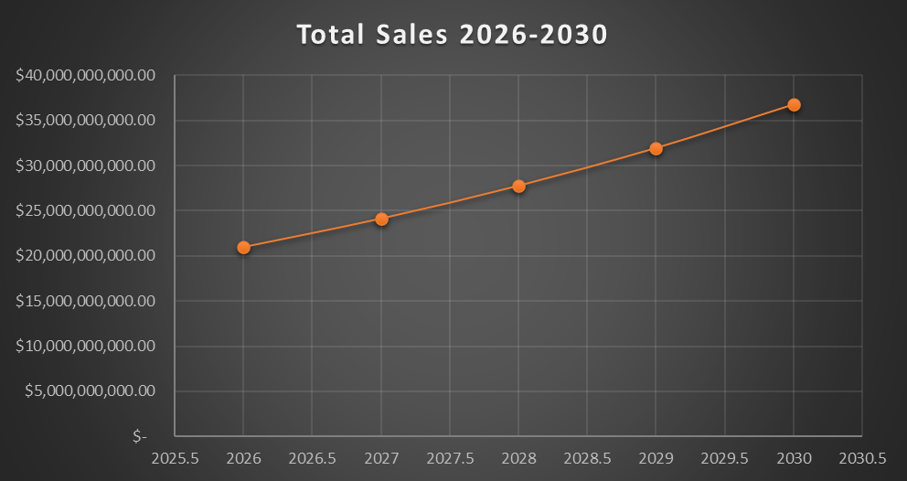

**References**

Sanofi. (2022). *Annual Report on Form 20-F.* [https://www.sanofi.com/en/investors/reports- and-publications](https://www.sanofi.com/en/investors/reports-%09and-publications).

Matt Timmermans. (2023, November 15). *Buy Property in Medan, Indonesia: Guide for Foreigners.* [https://ownpropertyabroad.com/indonesia/how-can-foreigners-buy- property-medan/](https://ownpropertyabroad.com/indonesia/how-can-foreigners-buy-%09property-medan/).

IFHP. (December 17, 2019). A*verage prices of Keytruda in selected countries in 2017 (in U.S. dollars)\** [Graph]. In Satista. https://www-statista- com.ie.idm.oclc.org/statistics/1089184/price-of-keytruda-by-country/.

WHO, & International Agency for Research on Cancer. (January 13, 2021). *Distribution of new cancer cases worldwide in 2020, by region* [Graph]. In Statista. https://www- statista-com.ie.idm.oclc.org/statistics/288813/new-cancer-cases-worldwide-by-region-in-percent/

Statista. (July 24, 2023). *Leading pharmaceutical companies worldwide based on market share in 2022* [Graph]. In Statista. https://www-statista- com.ie.idm.oclc.org/statistics/309425/prescription-drugs-market-shares-by-top- companies-globally/.

International Monetary Fund. (2023, October). East Asia, South-Eeast Asia and India real GDP growth, 1980-2028. World Economic Outlook (October 2023) Data Mapper. [Graph]. [https://www.imf.org/external/datamapper/NGDP_RPCH@WEO/IND/EAQ /SEQ](https://www.imf.org/external/datamapper/NGDP_RPCH@WEO/IND/EAQ%09/SEQ)

WHO, & International Agency for Research on Cancer. (January 13, 2021). *Predicted number of new cancer cases worldwide from 2020 to 2040* [Graph]. In Statista. https://www- statista-com.ie.idm.oclc.org/statistics/1031316/new-cancer-cases-forecast-worldwide/.

Vora, L. K., Gholap, A. D., Jetha, K., Thakur, R. R. S., Solanki, H. K., & Chavda, V. P. (2023). *Artificial Intelligence in Pharmaceutical Technology and Drug Delivery Design.*  Pharmaceutics, 15(7), 1916. <https://doi.org/10.3390/pharmaceutics15071916>.

Tannoury, M., & Attieh, Z. (2017). *The Influence of Emerging Markets on the Pharmaceutical Industry*. Current therapeutic research, clinical and experimental, 86, 19–22. <https://doi.org/10.1016/j.curtheres.2017.04.005>.

Seong, J., Bradly, C., Leung, N. (2023, September 22). *Asia on the cusp of a new Era*. McKinsey Global Institute. [https://www.mckinsey.com/mgi/our-research/asia-on- the-cusp-of-a-new-era](https://www.mckinsey.com/mgi/our-research/asia-on-%09the-cusp-of-a-new-era).

Saklayen M. G. (2018). The Global Epidemic of the Metabolic Syndrome. Current hypertension reports, 20(2), 12. <https://doi.org/10.1007/s11906-018-0812-z>.

Chew W.S., N., Chong, B. & Min Kuo Si (2023, May 30). *Trends and predictions of metabolic risk factors for acute myocardial infarction: findings from a multiethnic nationwide cohort.* The Lancet Regional Health. Western Pacific. Volume 37, 100803. <https://www.thelancet.com/journals/lanwpc/article/PIIS2666-6065(23)00121-9/fulltext>.

U.S. News. (2023). Best Global Universities for Artificial Intelligence. <https://www.usnews.com/education/best-global-universities/artificial-intelligence>.

Merck. (2023). *Financial Statements and report. Form 10-Q.*  [https://www.merck.com/investor-relations/financial-information/](%09https://www.merck.com/investor-relations/financial-information/).

Merck. (2022). *2022 Annual Report on Form 10-Q.* [https://www.merck.com/investor- relations/financial-information/](https://www.merck.com/investor-%09relations/financial-information/).

Asher Mullard. (2020, March 11). *$1.3 billion per drug?* Nature.com.<https://www.nature.com/articles/d41573-020-00043-x>.

Deep Pharma Intelligence. (2022). *Artificial Intelligence for Drug Discovery.* <https://www.deep-pharma.tech/ai-in-dd-q4-2022>.

1. You can see in the annex (Note 7) the different trends of metabolic diseases in different South-Asian nations. These trends would be used to support our thesis of why entering those markets would be very profitable, but can work for to further support the data given in this section.
2. Tables with R&D expenditures and Total Revenue projections from 2024 to 2027 are located in the Annex, Note 2.
3. This correlation was discovered when analyzing Merck’s financials. We created a chart with both variables so you can see it easier. See it in the Annex, Note 3.
4. S&P Global and Moody’s rate Merck as A+, the highest credit rating a firm can get. (S&P Global, 2023), (Moody’s, 2023).
5. The Inflation Reduction Act is going to be applied in several stages from 2022 to 2030, but it aims to cut down the costs of drugs. Its main objective is to avoid medicine prices to rise at an annual rate superior to the inflation rate (Merck, 2022).
6. See GDP charts of Indonesia, India and China, and the Asian Region in the Annex, Note 6.
7. A chart with the trend of these diseases in presented in the Annex, Note 7.
8. Map with the location of Medan in the Annex, Note 8.
9. See in the Annex how we have calculated this, Note 9.
10. See how we have made the calculations in the Annex, Note 10.
11. GDP per capita of our target countries has been obtained from the IMF (IMF, 2023).
12. See how we have calculated the average GDP per capita of our target market in the Annex, Note 12.
13. Go to Note 13 in the Annex.